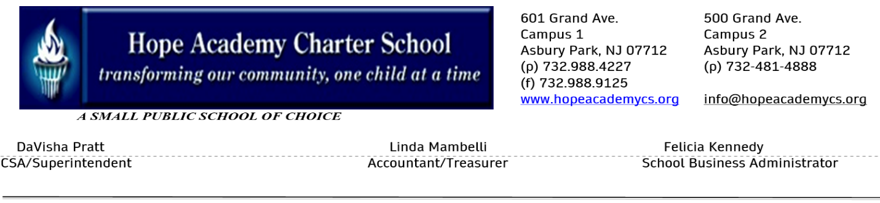
Hope Academy Charter School’s
Free Breakfast Program & Breakfast After-the-Bell
2022-2023
Breakfast time: 8-8:15am
After-the-Bell time: 8:16am-8:40am

